Integrated Safety Plan (ISP) Workbook

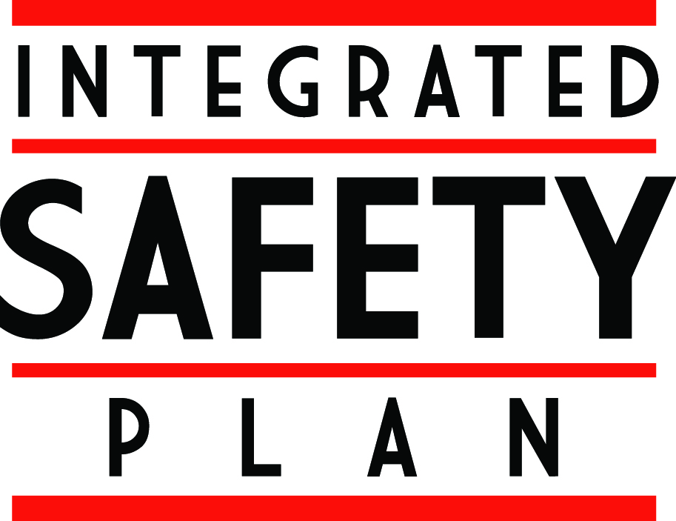

Developed by Penn State Environmental Health and Safety
March 2011



Introduction

This workbook has been developed in order to guide you through the process of implementing the Integrated Safety Plan or “ISP”. The ISP is an incentive based approach which promotes broader employee involvement in workplace safety and health. The basis of this plan is to create a partnership between EHS and participating units at the departmental level.

The ISP creates a “structure” for managing safety and health within the department. Taking a structured approach to safety and health will yield numerous benefits to the department including an enhanced safety culture, reduced risk of injury, and improved regulatory compliance. In addition to these benefits, EHS will offer financial incentives in the form of regulatory indemnification and cost sharing to those departments who effectively implement the ISP.

Under the ISP partnership, departments agree to implement three “core elements” in exchange for the financial incentives offered by EHS. The three core elements of the ISP are:

- Leadership Commitment
- Employee Involvement
- Self-Review

This workbook will review each of the three core elements and provide direction in how to effectively develop each element. It will also provide an overview of the benefits and incentives associated with the ISP.

EHS will serve as an active partner in the ISP process by providing tools, resources, and consultation to participating departments. EHS will also assess department efforts to determine whether or not the ISP criteria have been successfully met. Those departments that meet the criteria will be recognized as being “ISP certified” by EHS and thus become eligible for incentives.

Each core element has been broken down into distinct “phases” in order to ease implementation. A table depicting these phases has been included on page 3 of this workbook. Please note that there are no time limits associated with these phases; it is up to the department to decide how quickly they can effectively move through the process. As indicated on the table, EHS will grant the financial incentives to the department after completing the first phase of each element. In order to remain eligible for the financial incentives, the department must complete the remaining phases and then maintain them over time.

It must be stressed that EHS recognizes the need for flexibility when considering how to best implement each core element. We have attempted to take a non-prescriptive approach with this plan and will strive to work with each department to find the “best fit” for the ISP based on their work culture and circumstances.

 | Phase 1 | Phase 2
Leadership Commitment | - Visibly demonstrate leadership commitment to workplace safety and health  - Clearly assign and communicate safety responsibilities to all employees  - Ensure leadership is aware of relevant injury & illness statistics | - Implement system for ensuring employee responsibilities are met  - Integrate safety into planning processes  - Periodically establish safety goals and metrics for departmen
Employee Involvement | - Establish a departmental safety committee that effectively represents all employees  - Develop mechanisms through which all employees can effectively communicate safety concerns & offer suggestions for safety-related improvements | - Allow employees opportunities for direct involvement in safety efforts
Self-Review | - Identify general safety issues which impact department | - Identify program gaps  - Prioritize program gaps and develop implementation strategy for addressing  - Close program gaps
ISP Core Element and Phase Breakdown

Completion of Phase I “Leadership Commitment” & Phase I “Employee Involvement” items = Department eligible for indemnity
Completion of all Phase I items = Department eligible for cost sharing
Completion of all Phase II items = Department continues to remain eligible for indemnity & cost sharing

ISP Core Element # 1
Leadership Commitment

The first core element of the ISP is leadership commitment. Leadership alone can make safety a key business goal and provide the necessary resources to achieve safety objectives. Employees within every organization take their cues from administrators, managers, and supervisors. If leadership consistently treats safety as a priority, so will the rest of the work group.

In order to achieve and maintain ISP certification, the department must take the following actions relating to leadership commitment:

Leadership Commitment - Phase 1

- Visibly demonstrate leadership commitment to safety
- Clearly assign and communicate safety responsibilities to all employees
The first step in establishing the core element of leadership commitment is to ensure that all employees within the department know that there is administrative support of workplace safety and health. It is also critical that each employee understands what their role is within the overall safety effort. Both of these objectives can be accomplished through the development of an “ISP mission statement”.

An ISP mission statement is a concise document that serves as a summary of the department’s vision for safety and health. Page 10 of this document contains an “ISP Mission Statement Worksheet” that can be used as a tool in developing such a statement for your department. Once completed, this statement should be publicized and reviewed by each employee within the department.

Leadership commitment can also be demonstrated in a number of other ways beyond the establishment of an ISP mission statement. The following are some examples:

- Include safety as a routine agenda item at all staff meetings.
- Ensure that leadership sets a good example by consistently following all safety requirements (i.e. wear required protective equipment, use seat belt when driving, etc).
- Periodically visit work areas to provide safety feedback to employees.
- Make sure that leadership holds membership in the departmental safety committee and actively participates in committee activities.

- Ensure leadership is aware of relevant injury and illness statistics
Another key aspect of leadership commitment is maintaining an awareness of the injury and illness experience within the department. Injury and illness data can serve as a useful benchmarking tool and also help guide the allocation of resources within the department. EHS will compile relevant data and share this information with department leadership early in the ISP process. The ongoing tracking and sharing of this data will be a key component of the ISP effort.

Leadership Commitment - Phase 2

- Implement system for ensuring safety responsibilities are met
Once safety responsibilities have been established, there needs to be a system for ensuring these responsibilities are met by employees. Departments will be given flexibility in how to best achieve this, but there needs to be an understanding that there are consequences for those who choose to disregard their safety obligations. Some possible mechanisms to consider are as follows:

- Implement a specific system for ensuring safety responsibilities are met or incorporate safety as an element within an existing system for ensuring employee accountability. (Refer to existing disciplinary or incentive systems within the department).
- Incorporate safety as an element in job performance evaluations.
- Ensure that safety responsibilities are included as an element within written job descriptions.
- Track completion of safety responsibilities which are specifically assigned to individuals (i.e. completion of safety inspections, investigations, etc).

- Integrate safety into planning processes
- Periodically establish safety goals and metrics for the department
The second phase of effectively implementing the core element of leadership commitment also includes the integration of safety into planning processes. Departments must “look ahead” to ensure that safety is part of the overall mission of the organization and that necessary resources are available to meet safety needs. Some mechanisms for integrating safety into planning processes include the following:

- Ensure a schedule is in place for meeting routine safety requirements (i.e. annual training, inspections, program reviews, etc).
- Ensure that adequate resources are available to address anticipated safety-related expenses.
- Establish safety metrics for the department and ensure that these are tracked on an ongoing basis. Metrics should be based on a combination of “leading” and “lagging” indicators. (EHS can provide assistance in establishing and tracking safety metrics for the department).
  - “Leading” indicators might include safety achievements such as the number of inspections completed, hours of training provided, or number of hazards eliminated over a given period of time.
  - “Lagging” indicators could include the number of injury reports, OSHA recordable cases, days away from work, or near-misses over this same time period.
- Establish specific objectives for safety improvement based on the results of the ISP self-review process.

ISP Core Element # 2
Employee Involvement

Employee involvement is the second core element of the ISP. Leadership commitment and employee involvement are complementary forces. Leadership commitment provides the motivating force and the resources for accomplishing safety objectives within an organization. Employee involvement provides the means through which employees develop and express a commitment to workplace safety.

In order to achieve and maintain ISP certification, the department must take the following actions relating to employee involvement:

Employee Involvement - Phase 1

- Establish a departmental safety committee
The first step in implementing the core element of employee involvement is the establishment of a departmental safety committee. This committee will serve a key role within the ISP by meeting regularly to discuss safety issues within the department.

The departmental committee will also act as a conduit for exchanging safety information both within and outside the department. The diagram on page 12 shows the safety committee structure at Penn State. As can be seen, the departmental committee is expected to maintain two-way communication not only with the college/work unit safety committee but also with internal employees through their supervisors.

The committee must meet on a regular basis and adequately represent all employees within the department. Minutes must be kept of each committee meeting and be available for review by EHS. Page 13 contains some basic tools for developing a departmental safety committee, including the following information:

- Suggested list of committee responsibilities
- Guidelines for committee structure and meeting frequency
- Meeting agenda template (can be used to document each meeting)

- Develop methods of safety communication
Developing clear lines of communication on safety issues is a critical means of learning about potential hazards within a department. It also provides an effective mechanism for involving employees by encouraging them to bring forth safety concerns or suggestions.

The most basic way to enable effective communication is to make certain that employees know who they should contact with safety input. This normally would be their immediate supervisor or manager. Employees should also be aware of other resources available to them such as the college or unit safety officer, the departmental safety committee, and EHS. Consideration should be given to the fact that some employees may wish to remain anonymous when reporting concerns.

The primary motive in accomplishing this phase should be to ensure that employees know where to go with safety concerns and feel comfortable in sharing this information. There are a number of other communication mechanisms that can be considered by the department; the goal should be to find the best “fit” based on the department size and culture.

Some options for gathering safety feedback from employees are as follows:

- Suggestion boxes
- Specific web site or e-mail address for safety issues
- Safety work order system
- Newsletters
- Include safety as a routine agenda item at all staff meetings
- Schedule periodic meetings solely for the discussion of safety issues

Employee Involvement - Phase 2

- Involve employees directly in safety efforts
The ultimate goal of the core element of employee involvement is to have employees actively engaged in departmental safety efforts. The intent of this phase is not to delegate safety responsibilities to employees, but rather to take advantage of their unique insights when evaluating safety issues. This is a phase that may need to be implemented over time as new opportunities for involving employees evolve. Some means for directly involving employees in safety efforts are as follows:

- Involve employees in completion of workplace safety inspections
- Obtain employee input when developing safety training materials
- Gather employee feedback when developing safety policies or procedures
- Ensure employees participate in the ISP self-review

ISP Core Element # 3
Self-Review

Completion of periodic self-reviews is the third core element of the ISP. Participating departments must review their internal operations in order to identify potential hazards and compliance gaps. The self-review process is initially geared towards assessing program gaps and must be complemented by periodic worksite inspections. Objectives for program implementation and continual improvement can be developed based on the self-review results, thus creating safer workplaces.

Self-Review Phase 1

- Identify general safety issues affecting department
The first step of the self-review is to simply identify what broad safety issues exist within the department. The purpose in doing so is to create somewhat of a “safety inventory” that can then be further examined in the next phase. The form on page 15 can be used to complete this initial step of the self-review element.

Self-Review Phase 2

- Identify program gaps
- Prioritize program gaps
The second phase involves a closer evaluation of the safety issues identified during the previous step. Excerpts from the form used to complete this evaluation can be found on page 17. As can be seen, this form is designed to provide the user with an indication of whether the key requirements of each program are being met. Items which are marked as “No” indicate potential hazards and/or compliance issues. A timetable for addressing these items must be established based on a priority schedule developed by the department in conjunction with EHS.

- Close program gaps
The final step of the self-review core element involves closing the program gaps identified during the previous phase. Items must be addressed within a reasonable time frame based on the priorities jointly established by the department and EHS.

The self-review process must be repeated on an annual basis. This will ensure that previous gaps have been addressed and that programs are effectively maintained over time. The goal of the self-review element is to continually improve over time. Therefore, other means for hazard identification should be incorporated into this element:

- Periodic completion of worksite inspections (inspection forms are available from EHS)
- Management of change (safety reviews of new equipment, processes, work areas, etc)
- Investigation of all injuries, illnesses, and near-miss incidents
Indemnification Benefits of ISP
Departments that successfully implement the first phase (see page 3) of both the “Leadership Commitment” and “Employee Involvement” core elements will be indemnified against the cost of regulatory fines related to programs overseen by the PSU Department of Environmental Health and Safety. This includes fines issued by the following groups:
- Occupational Safety and Health Administration (OSHA)
  - 29 CFR 1910 Occupational safety and health standards for General Industry
  - 29 CFR 1926 Occupational safety and health standards for Construction
  - 29 CFR 1928 Occupational safety and health standards for Agriculture
- Nuclear Regulatory Commission (NRC)
- Environmental Protection Agency (EPA)
  - Underground and aboveground tank management
  - RCRA (Hazardous waste management)
  - Asbestos management
- Pennsylvania Department of Environmental Protection (PA DEP)
  - Infectious waste management
  - X-ray producing equipment
  - Radioactive materials use
  - Asbestos management
Indemnification will ensure that any monetary fines levied on the University as a result of violations within a covered department will not be entirely charged back to the department. This indemnification will remain in effect as long as the department continues to meet the criteria for certification, including the following:
- The departmental safety committee must continue to meet regularly and meet the responsibilities outlined on page 13.
- Annual self-reviews must be completed within the department.
- Safety concerns and suggestions must continue to be effectively communicated within the department.
The department must also successfully pass periodic audits of their ISP conducted by EHS.

Cost Sharing Benefits of ISP

Departments that successfully implement the first phase of all three core elements (see page 3) will be eligible for cost sharing. Cost sharing is intended to support new and existing programs that have broad safety implications within the department. Contact EHS for further information on what costs are eligible for coverage under the ISP.

Appendix A
ISP Mission Statement Worksheet

The establishment of an “ISP mission statement” is the first step in implementing the Integrated Safety Plan within a department. The general purpose of such a statement is to express leadership’s commitment to workplace safety and health. It must also clarify safety and health responsibilities throughout the work group. It should be viewed as a concise (usually one page) document that summarizes the group’s support of the Penn State Environmental Health and Safety Policy, which can be accessed at http://guru.psu.edu/policies/SY01.html.

This worksheet is intended to help you develop your statement. It has been split into the following four headings: introduction, purpose/goal, safety responsibilities, and closing. Each of these sections includes excerpts from other statements. These are examples only, but they may give you ideas for developing a statement that expresses your style, your attitudes, and your values.

Introduction:
The written statement generally starts with a clear, simple expression of your concern for employee safety and health. Examples of statement introductions are as follows:

- It is the policy of this department to provide a safe and healthy workplace for all employees.
- This department considers no phase of its operation or administration more important than safety and health. We will provide and maintain safe and healthy work conditions, and we will insist on safe work methods and practices at all times.
- This department has always believed that our employees are our most important asset. We will always place the highest priority on safe operations and the safety and health of employees.

Purpose or Goal:
Effective safety and health efforts will have a stated purpose. This is included so that all employees are clear on why resources are devoted to safety. You may want to consider incorporating material similar to the following:

- Our objective is to have a safety and health system which will minimize losses with an ultimate goal of zero work-related injuries and illnesses.
- We have established our safety and health system to eliminate work-related injuries and illnesses. We expect it to improve operations and reduce personal and financial losses.

Safety Responsibilities:
The statement needs to describe in general terms what the safety responsibilities are at each level of the department. It should not include a detailed list of all responsibilities, but rather give each individual a basic understanding of what their role is within the overall safety effort. This portion of the statement is often broken down in terms of management, supervisory, and employee responsibilities:

- Management is responsible for leadership of the overall safety effort and providing all resources which are necessary for an effective program of accident prevention.
- Supervisors are responsible for maintaining safe work conditions within their areas and for ensuring that all operations are carried out with the utmost regard for safety.
- Each employee is responsible for consistently following all established safety procedures and for promptly reporting potential hazards.

You might also wish to mention the safety committee within this section and define what their role is within the department.

Closing:
The closing is a reaffirmation of the department’s commitment to a safe and healthy workplace. It may also offer an appeal for the cooperation of all employees in supporting safety efforts. Examples are as follows:

- All employees are strongly urged to make safety and health an integral part of their daily activities.
- By accepting mutual responsibility to operate safely, we will contribute to the well-being of one another and consequently the entire University.
- The safety and health efforts within this department are intended to protect our most valuable asset: our employees. Maintaining a safe work environment is a top priority of leadership and must be a personal goal of every employee.

Once the ISP mission statement is finalized, it should be publicized within the department. Ensuring that all employees are aware of leadership’s commitment to safety and understand their role within this effort will form the basis for moving forward with the ISP. Please contact the Department of Environmental Health and Safety (EHS) for assistance in creating your statement.

Appendix B
Safety Committee Structure at PSU

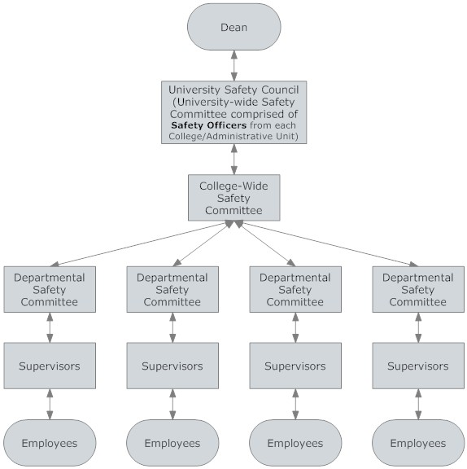

Appendix C
Departmental Safety Committee Information

Committee Responsibilities: The following is a list of suggested responsibilities that can be adopted by a departmental safety committee:
- Define committee responsibilities and incorporate these into the ISP mission statement
- Establish effective communication plans for safety issues
- Review safety concerns and suggestions made within the department
- Track information recorded during ISP self-reviews and participate in prioritizing gaps
- Evaluate compliance with established safety programs, policies, and rules
- Develop mechanisms to implement new safety policies and procedures within the department
- Ensure safety training needs within the department are met
- Review injury reports and trends within the department
- Exchange relevant information with the college/work unit safety committee
- Establish goals that support the college/work unit goals
- Identify the most critical safety issues for focus and funding
- Help define feasible solutions to safety issues in cooperation with EHS
- Maintain records of all committee meetings
Meeting Agenda Guidelines: The following is a list of recommended agenda items for departmental safety committees:
- Review minutes of previous meeting
- Review communication of safety issues, policies, or procedures within the department
- Discuss accident reports and trends, causes of accidents, and preventive/corrective actions
- Review unsafe conditions reported within the department and how addressed
- Discuss emergency response issues pertinent to the department
- Share inspection results (internal, insurance company, etc.) and coordinate follow-up
- Reserve time to cover a specific “safety topic” at each meeting (guest speaker, training, etc)

Guidelines for Safety Committee Structure: The following are basic guidelines for determining the membership of departmental safety committees:
- Membership should consist of five to fifteen individuals, each representing various areas within the department.
- One member of the departmental safety committee should also serve as a representative on the college/work unit safety committee.
- Management and employees should be equally represented on the committee. Faculty members should be included along with union members if the work unit is represented by a labor union.
- The committee should consider forming subcommittees when appropriate for larger tasks or initiatives.
Guidelines for Frequency of Meetings: The following are basic guidelines for determining how often departmental safety committees should meet:
- Each departmental safety committee should meet on at least a quarterly basis.
- More frequent meetings may be appropriate depending on the nature of operations, number of employees, etc.
- Other functions can occur between safety committee meetings as needed.
Meeting Documentation: Each meeting of the departmental safety committee must be documented. A template is available from EHS to assist committees in meeting this requirement.

Appendix D
ISP Self-Review, Part I

The Integrated Safety Plan (ISP) at Penn State is based upon the implementation of three core elements: Leadership Commitment, Employee Involvement, and Self-Review. This document serves as the initial step in completing the self-review process. The purpose of this form is to identify the general safety issues that impact participating departments.

Each question should be answered with either a “Yes” or “No” response. Questions which generate a “Yes” response will be further evaluated in Part II of the self-review process.

 | Yes | No
- Are there any recognized hazards within this department that require the use of personal protective equipment (PPE)?
- Does this department include any laboratory areas?
- Does this department use or store any chemicals in non-laboratory areas?
- Does this department have any employees who could be exposed to blood or infectious bodily fluids during the course of their work?
- Does this department include any laboratories where hazardous biological materials are used?
- Does this department generate any infectious waste?
- Do emergency evacuation plans need to be developed for any areas within this department?
- Does this department have any employees who perform electrical work?
- Do any departmental employees access unguarded locations six feet or more above lower surfaces?
- Do employees in this department use powered industrial trucks?
- Do employees in this department use any form of aerial lift equipment?
- Does this department have any fixed machinery or equipment which is operated by employees?
- Do employees in this department service or maintain equipment which could cause injury if unexpectedly energized?
- Do employees within this department enter confined spaces?
- Are there any respiratory hazards associated with department work activities (harmful dusts, fumes, mists, smokes, sprays, or vapors)?
- Are employees in this department involved in any asbestos-related activities?
- Are employees in this department exposed to noise levels greater than 85 decibels averaged over an eight-hour shift?
- Do employees in this department complete any hot work (i.e. welding, cutting, soldering, grinding, etc)?
- Does this department have or use any lasers?
- Does this department have or use any radioactive materials, including sealed sources in machinery or equipment?
- Do employees in this department use any x-ray producing equipment?
- Does this department generate any hazardous waste?
- Do employees in this area ship hazardous materials, chemicals, biological materials, dry ice, dangerous goods, research samples, or diagnostic specimens off-site?
- Does this department have any non-mobile, fixed tanks with a capacity greater than 55 gallons?
- Do employees in this department use, transport, mix, or apply pesticides or enter plots that have been treated with pesticides?
- Does this department have any employees directly exposed to live animals, animal bedding, animal tissue, or animal fluids?
- Are there any ergonomic or material handling issues within this department?
- Are there any other unique safety hazards within this department? (If “Yes”, provide further information in “Comments” section)

Comments
(Please include any additional information related to your responses that you feel will be helpful)

Self-Review Completed By:

Completion Date:

Appendix E
ISP Self-Review, Part II

Note: The following are excerpts from Part II of the Self-Review; the full version is available from EHS.

10. Powered Industrial Trucks (EHS Powered Industrial Truck Program) | Y | N
10.1 Do employees in this area use powered industrial trucks?
If you answered “No” to questions 10.1, you may skip to the next section
10.2 Are all operators trained to safely use powered industrial trucks (classroom and hands-on training)?
10.3 Do all operators have their driving skills evaluated at least every three years?
10.4 Are lift trucks inspected prior to use on each shift?
10.5 Are lift truck pre-use inspection records kept for one year after completion?
13. Lockout/Tagout (GURU Policy SY35) | Y | N
13.1 Do employees in this area service or maintain equipment which could cause injury if unexpectedly energized?
If you answered “No” to question 13.1, you may skip to the next section
13.2 Do employees receive lockout/tagout training prior to being permitted to service equipment?
13.3 Have authorized employees been provided with standardized locks and tags?
13.4 Have authorized employees been provided with lockout devices suitable for all equipment which they service?
13.5 Are authorized employees evaluated on an annual basis?
13.6 Have equipment-specific lockout/tagout procedures been developed?
13.7 Are affected and other personnel given lockout/tagout awareness training?

 | 18. Hot Work (EHS Hot Work Permit Program) | Y | N
 | 18.1 Do employees in this area complete any operations producing flame, sparks, or heat (such as welding, cutting, brazing, grinding, sawing, torch soldering, thawing frozen piping, applying roof materials, etc)?
 | If you answered “No” to question 21.1, you may skip to the next section
 | 18.2 Have areas for completing hot work been designated by the department?
 | 18.3 Is all hot work outside of designated areas completed in accordance with the permit system?
 | 18.4 Have employees been trained in usage of the hot work permit system?
 | 18.5 Is a copy of each completed permit submitted to the EHS Department?

